30/10/2020

CMP4271 Professional Practice for Games Development

Task 5 – Playtesting

5.0 Introduction

The premise was to make a questionnaire for a game that is classed as a “serious” game, which basically means a game with an educational aspect. The game was Minecraft and the questionnaire asked questions to evaluate if the game is both enjoyable and has any educational aspects. There were eleven responses to the questionnaire in total.

5.1 Questionnaire

The questionnaire was created on Google Drive. There were 8 questions in total.

* How often do you play Minecraft on a monthly basis?
* What do you think of the General Gameplay of Minecraft?
* What do you like the most about Minecraft?
* What do you dislike about Minecraft?
* In your opinion, how do you think Minecraft can be improved as a game?
* What skills do you feel you have developed from playing Minecraft?
* Are there any other skills you can list that you feel you have learned?
* Why do you feel you have gained these skills?

5.2 Results

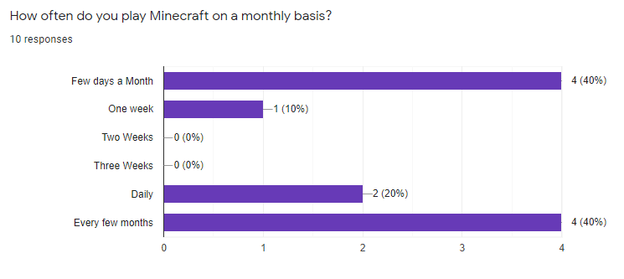

Figure 5.1a. Results and Responses. This figure shows the results and responses for how often people play Minecraft on a monthly basis.

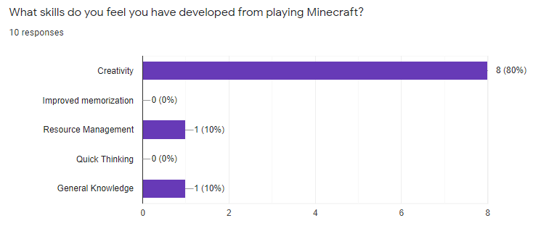

Figure 5.2a

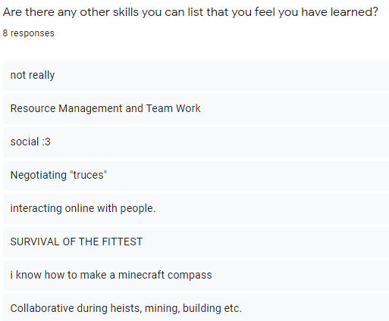

Figure 5.2b

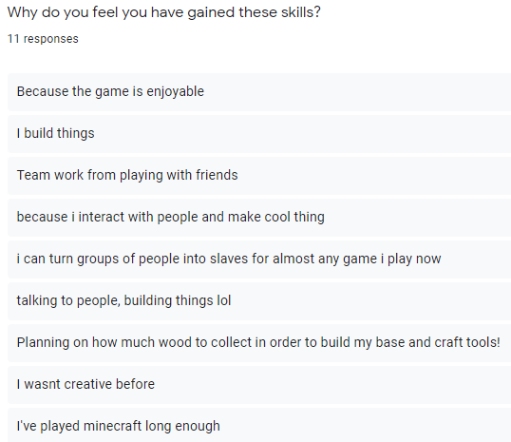

Figure 5.2c

Throughout Figure 2 shows the response the team received from players about the skills they developed while playing the game and how they believe the game helped develop these skills.

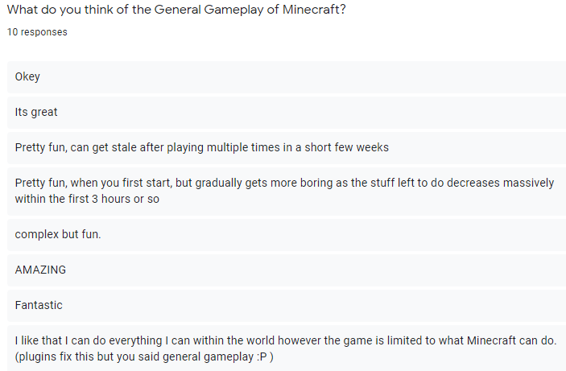

Figure 5.3a. General Gameplay Response. This figure shows the opinions of people towards the general gameplay of Minecraft.

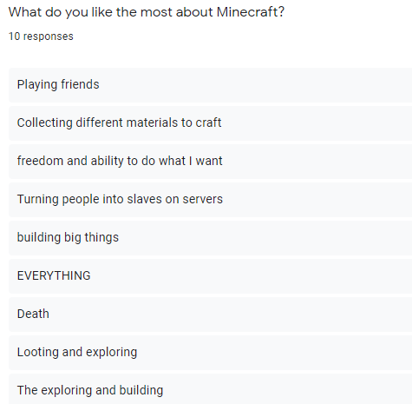

Figure 5.3b. Reason for playing Minecraft. This figure shows the people’s most liked reason for playing the game

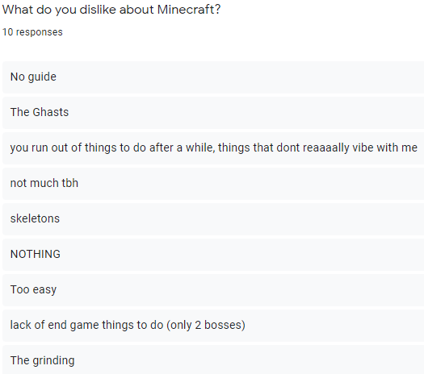

Figure 5.3c shows what people dislike about Minecraft

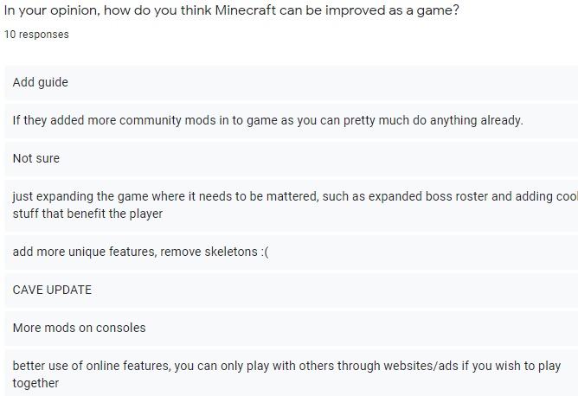

Figure 5.3d shows what people think can improve the game.

5.3 Discussion

From this questionnaire, Minecraft was a success for being educational as it helped the players become more creative, memorise the many aspects of the game such as recipes or biomes and learn how to manage their resources. It is also enjoyable, but there were also many ways added that could improve, such as the lack of a guide or the game only having two bosses.

5.4 Reflection

The group I had worked with was Ngozi Egonu and Connor Winspur. What I would do differently for this questionnaire would be allowing the players to provide multiple responses to a question and making sure it works before sending it to others. I would also make the questions a bit more direct so people don’t go off topic from the main question.